**Lab 1: Create Simple bucket, Upload File and access the file. [ACL Enabled]**

**Successfully created bucket.**

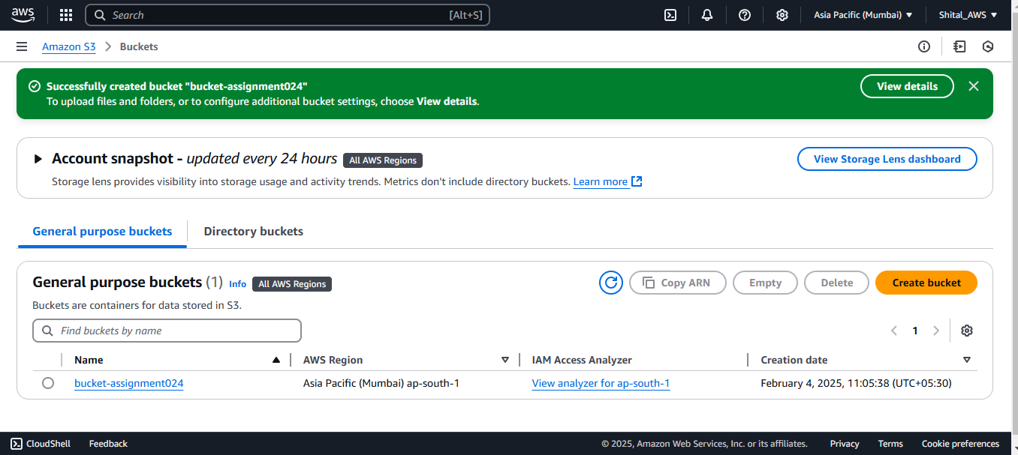

**Uploaded file**

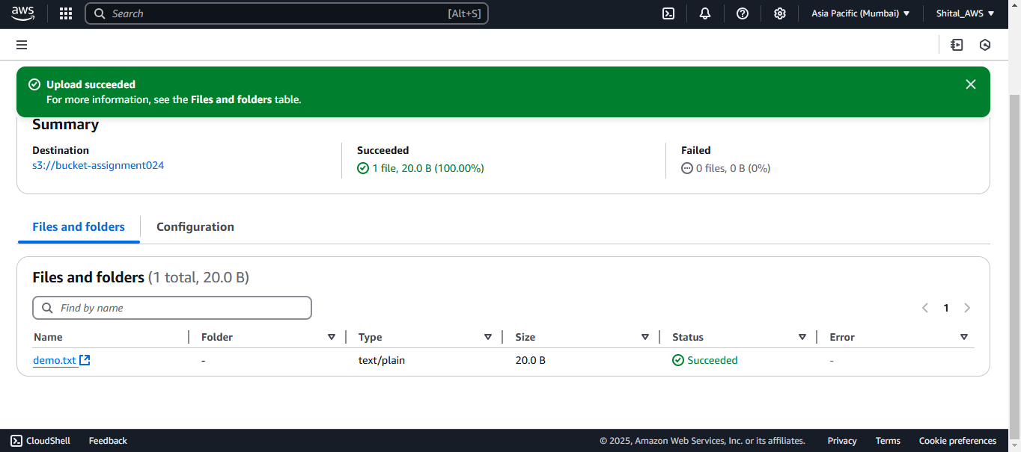

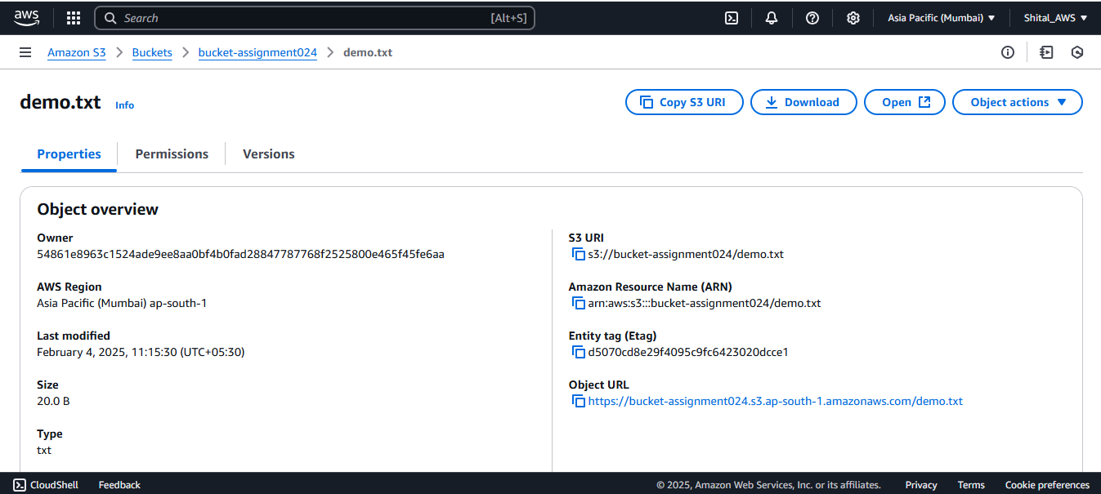

**File publically not accessible**

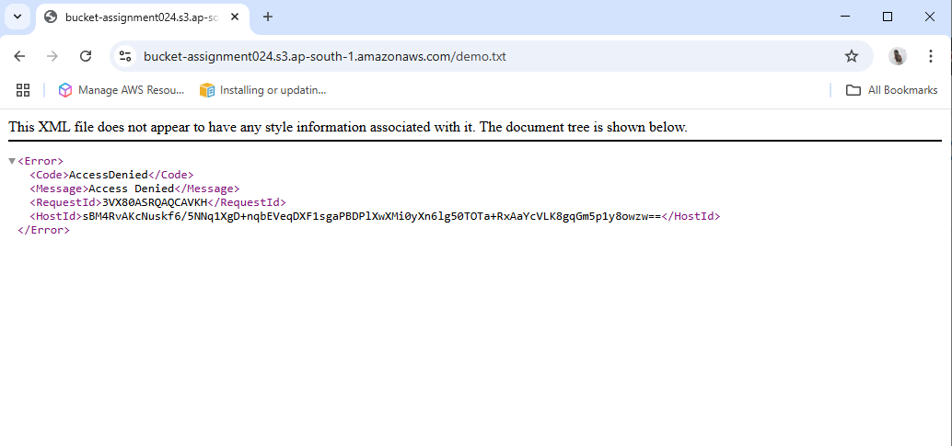

**To make public**

**Block public access de-selected**

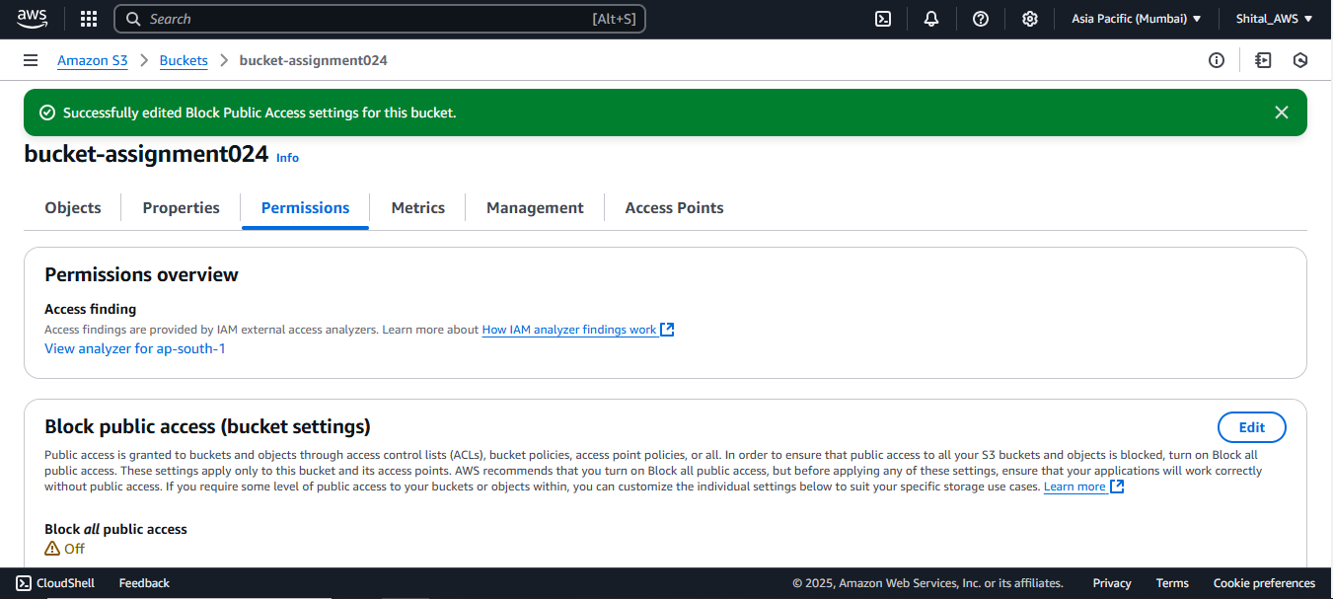

**File is not accessible**

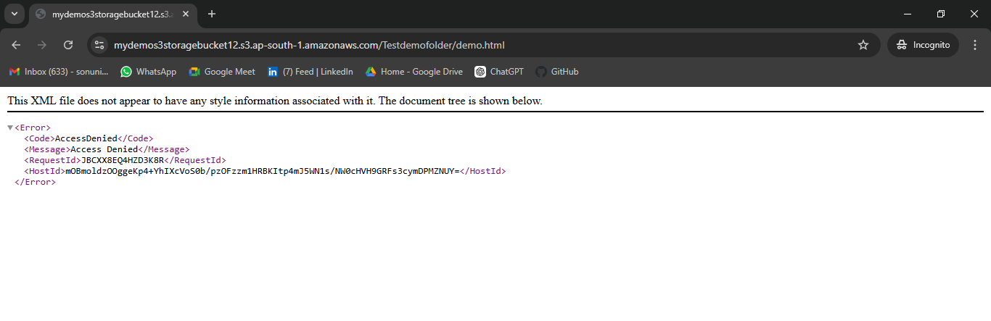

**Make file pubic**

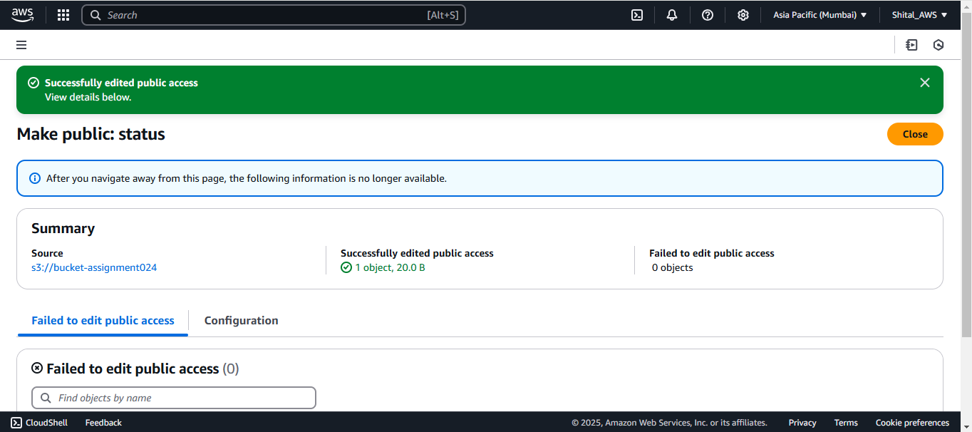

**Object URL is accessible**

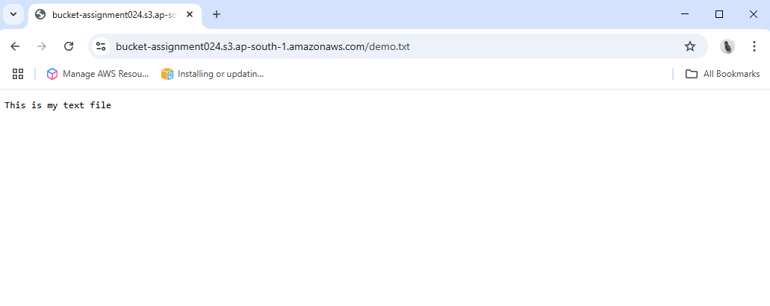

**Another way to make file public.**

**Block public access selected**

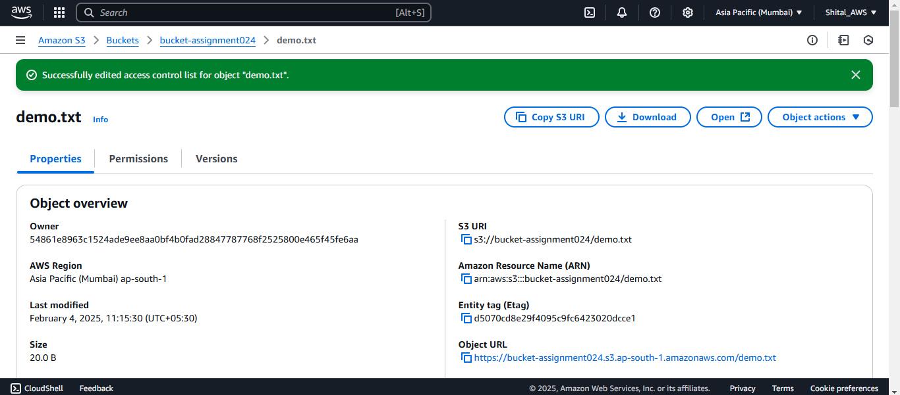

**2. Create Simple bucket, Upload File and access the file Public Object by Using [Bucket Policy]**

**Created bucket**

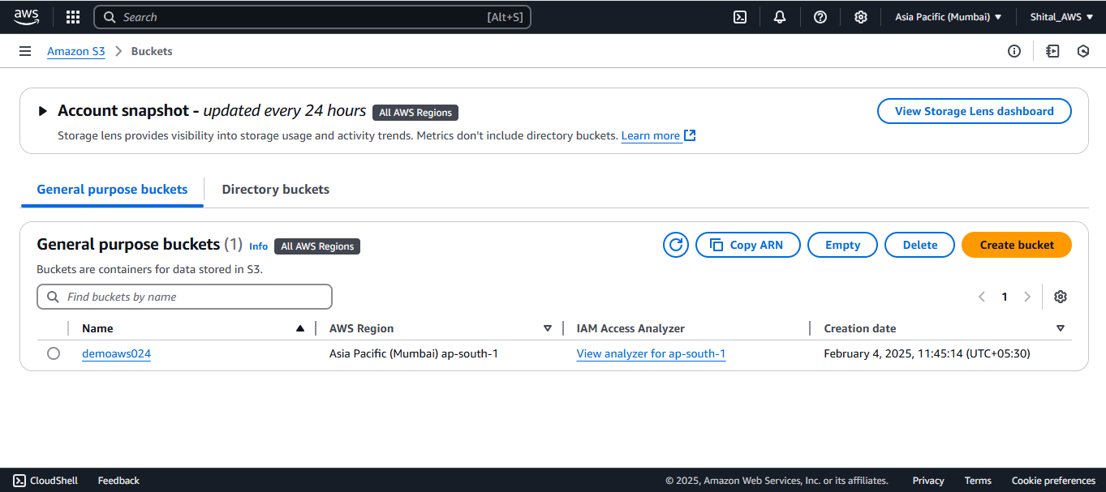

**Uploaded file**

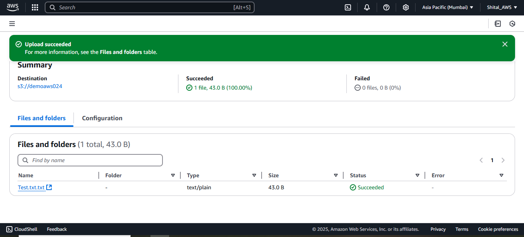

**Created bucket policy**

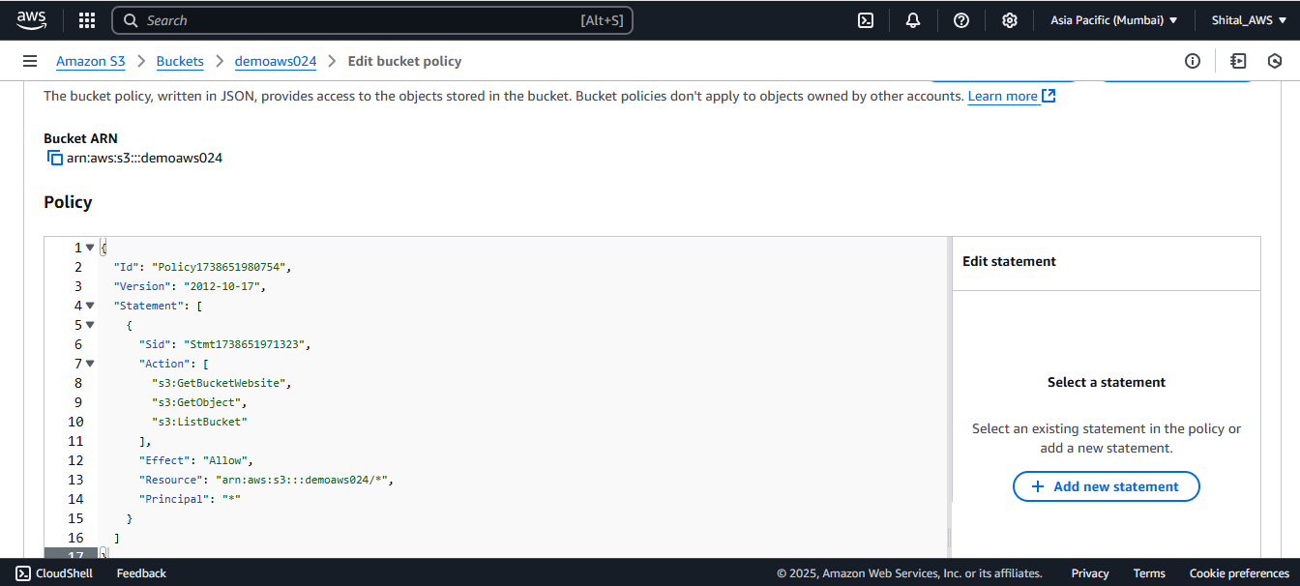

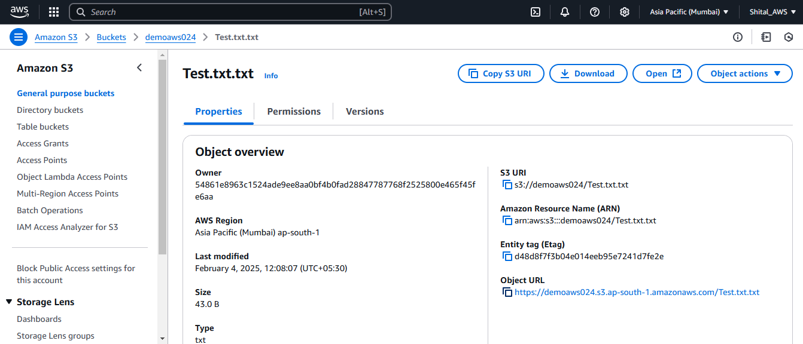

**Object url accessible**

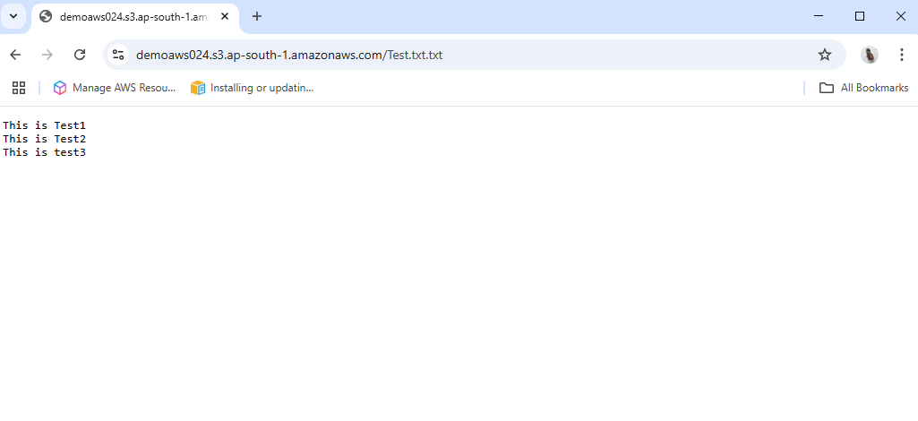

**Lab 3: S3 Bucket Versioning**

**Created bucket**

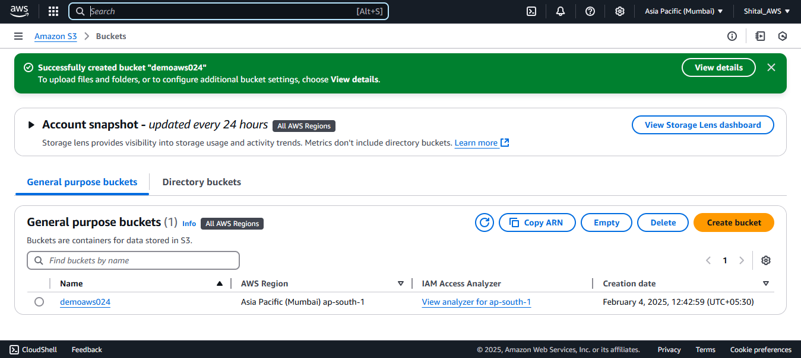

**File uploaded**

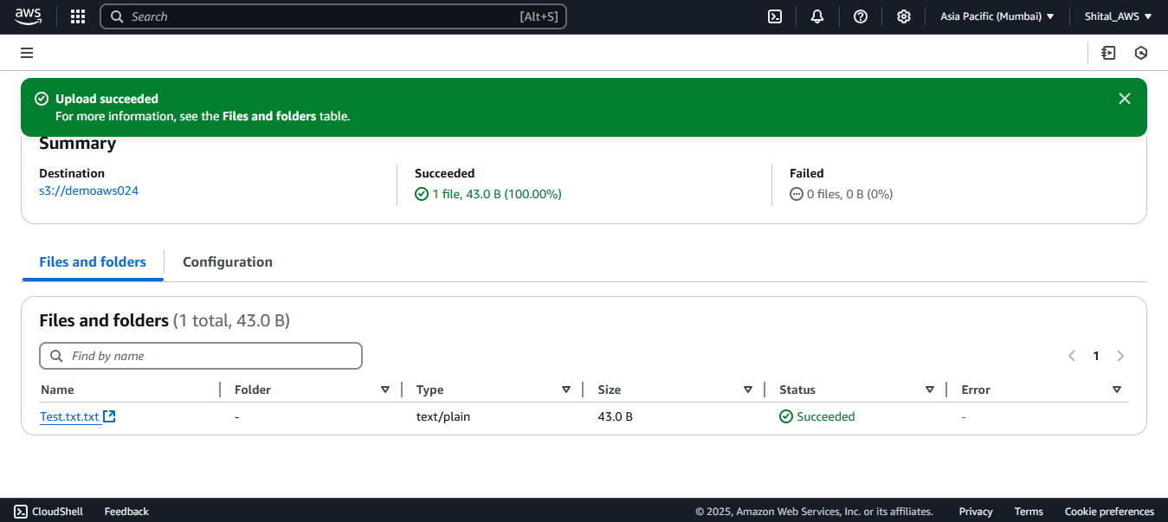

**to make public**

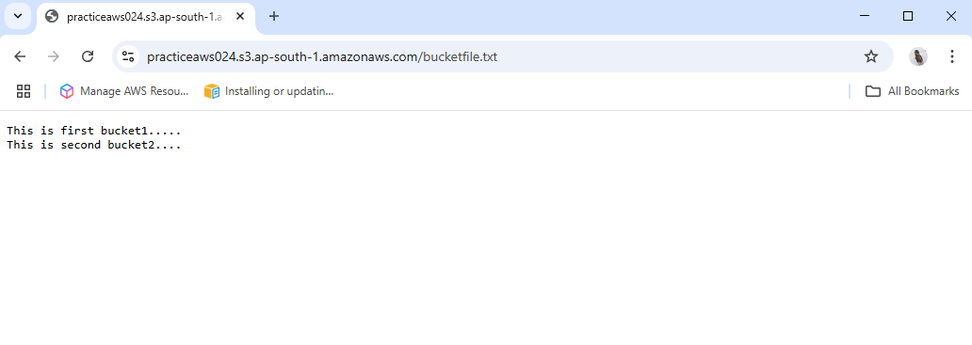

**Making bucket versioning enable**

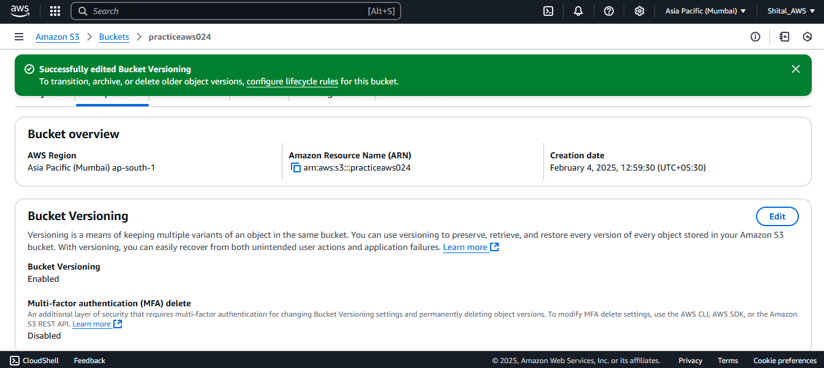

**Uploaded second file (edited file)**

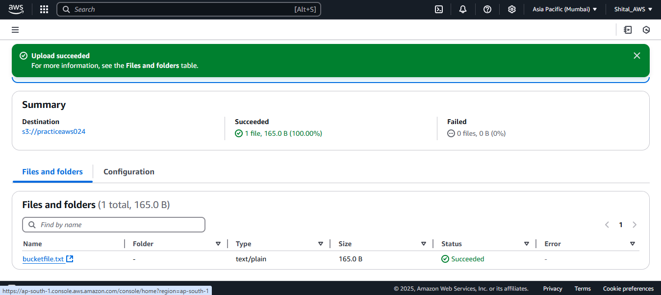

**Created version of actual file**

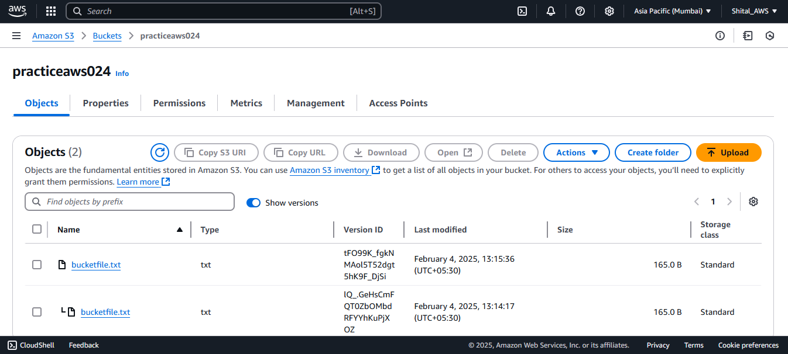

**file publically accessible**

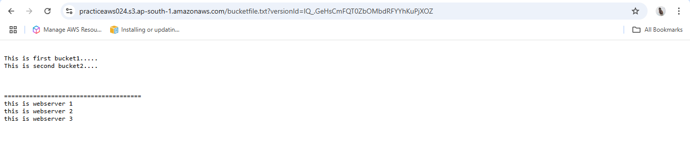

**Actual version deleted**



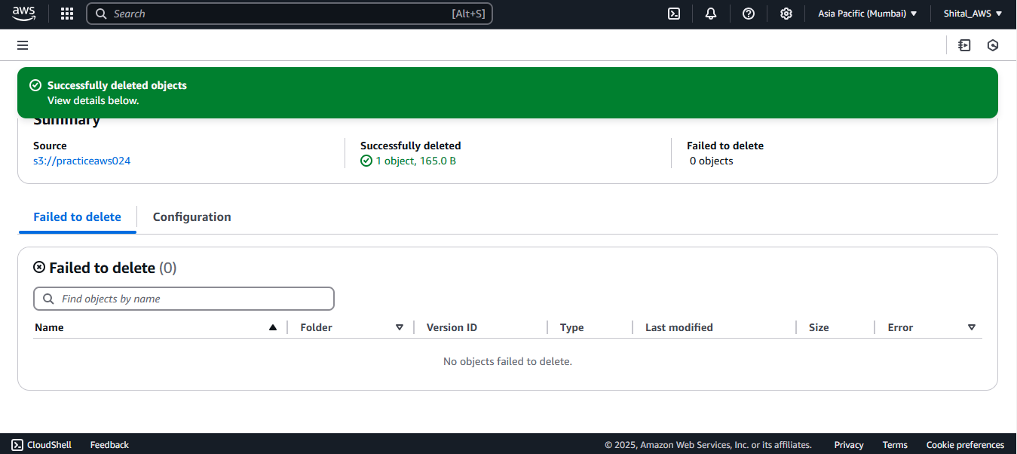

**But version remains exists**

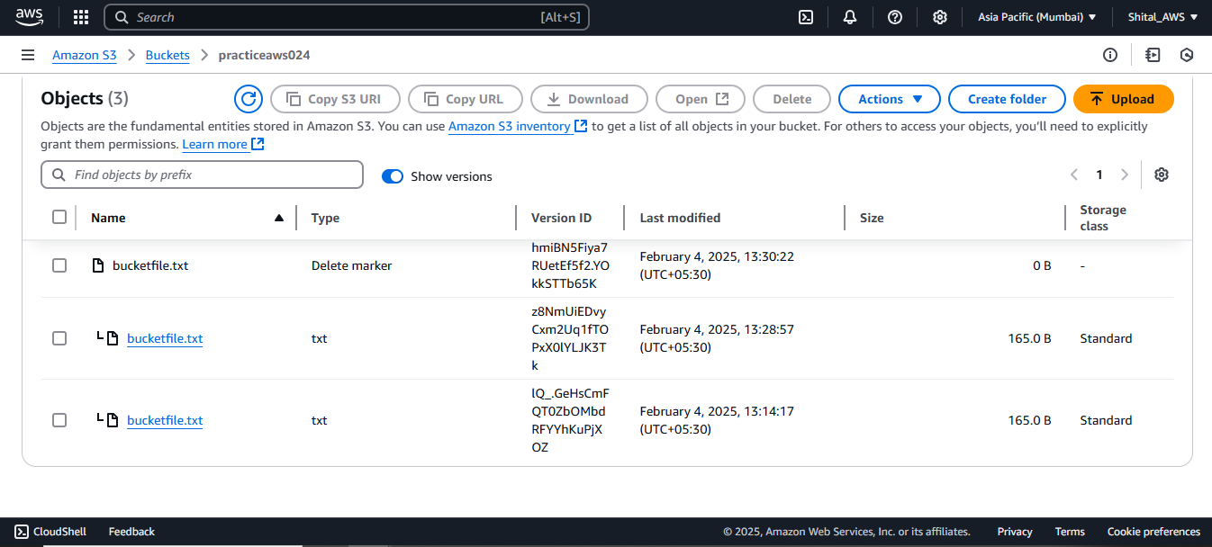

**Lab 3: S3 Bucket Cross Region Replication**

**Created source bucket in Mumbai region and Created target bucket in N.vergania**

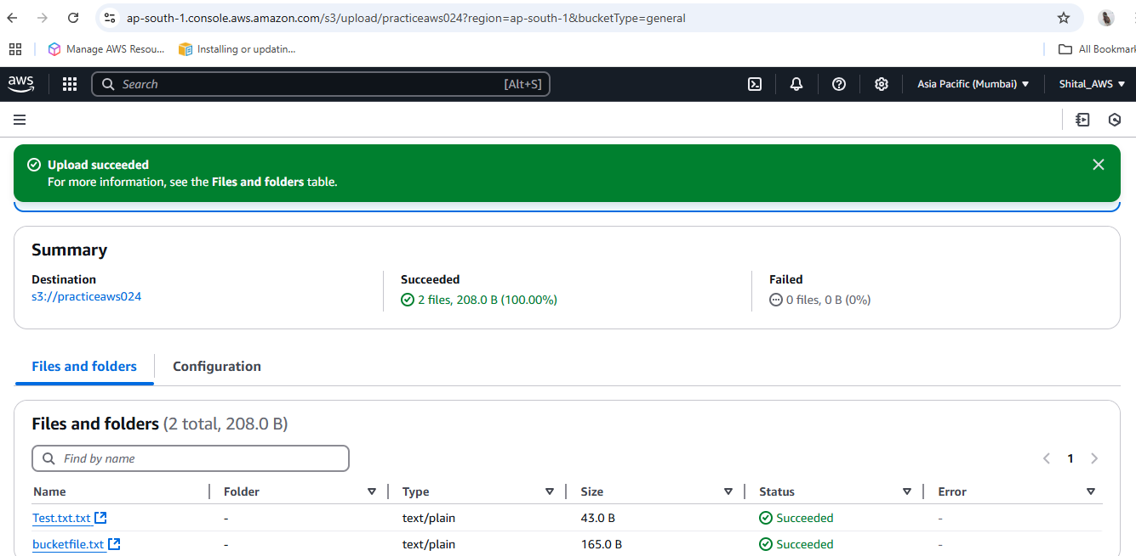

**Created replication rule in source bucket**

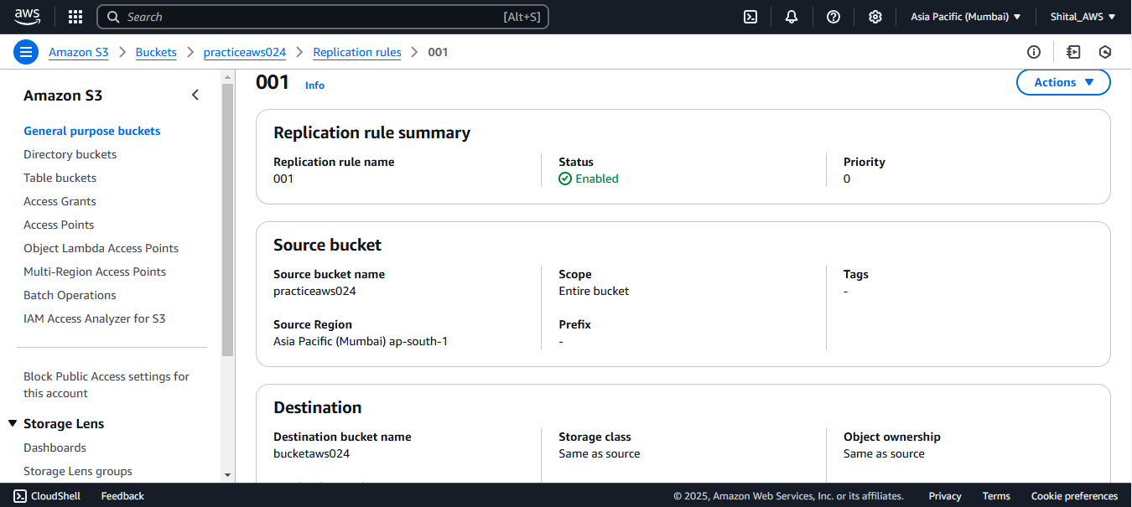

**Uploaded object in source bucket**

**Given public access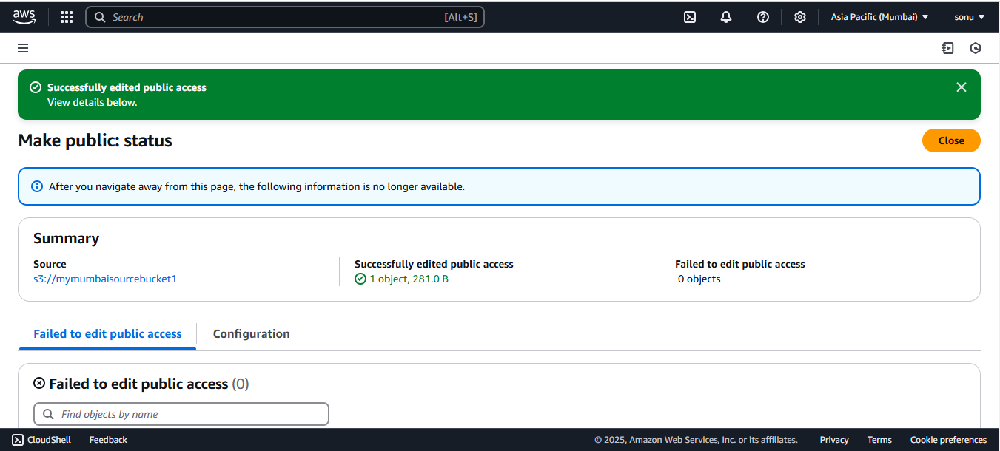Object get copied in target bucket automatically**

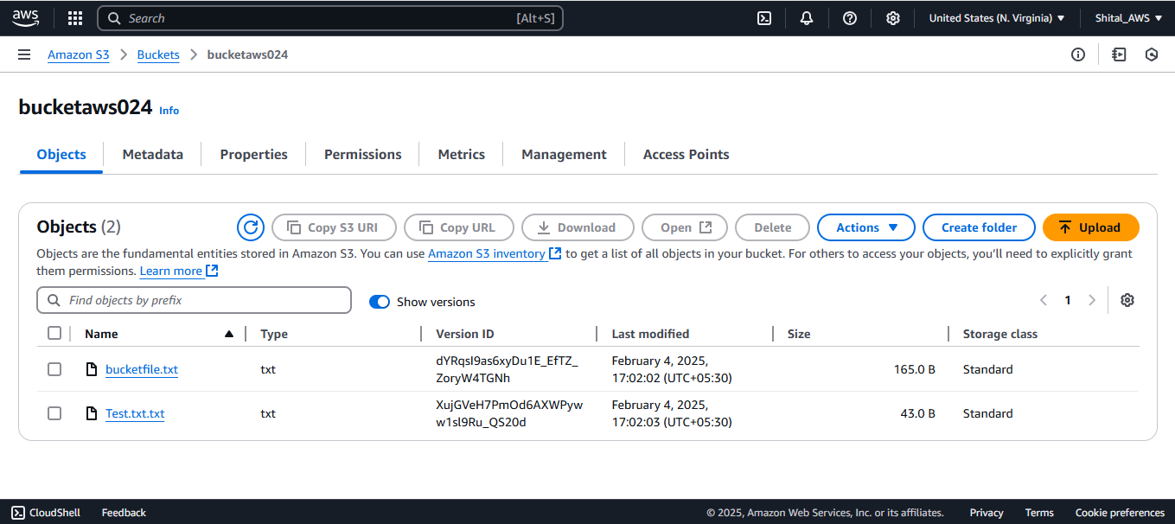

**Lab 4: S3 Bucket Object Life Cycle Management**

**Created bucket**

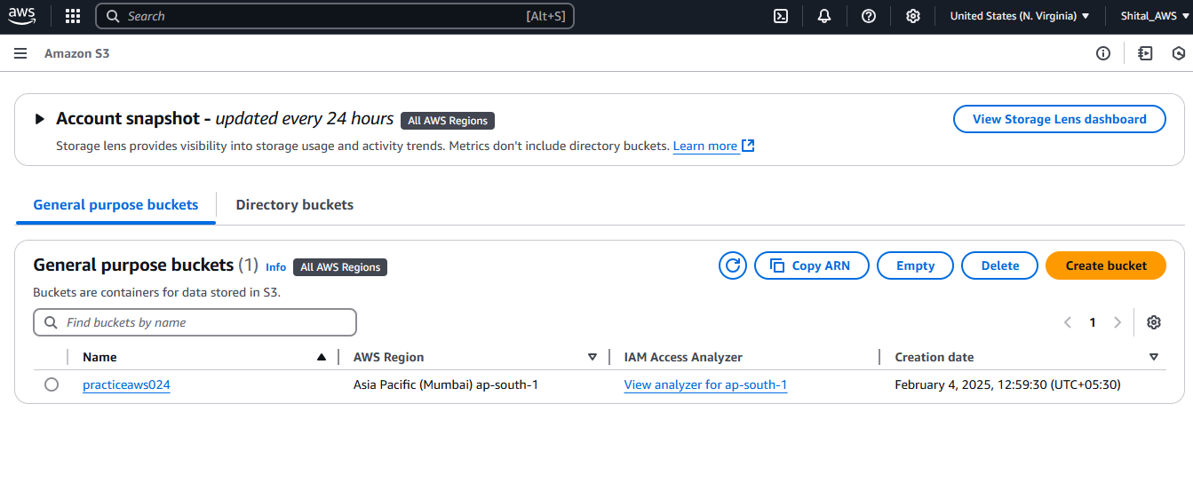

**Created lifecycle rule**

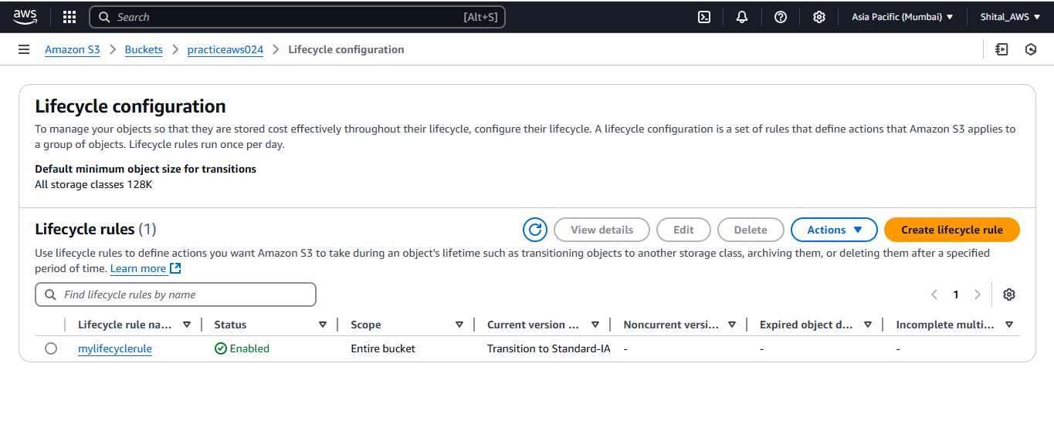

**Lab 5: S3 Static Web Site Hosting**

**Created bucket**



**Uploaded objects**

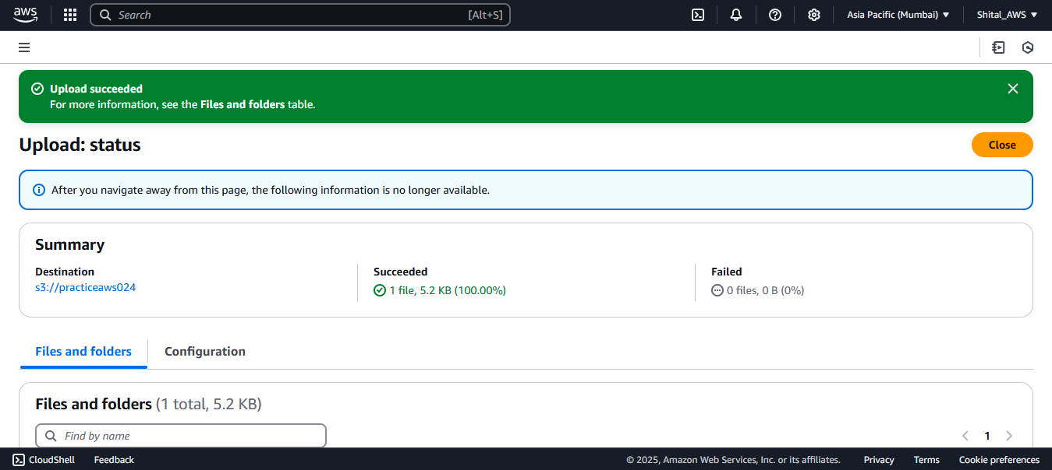

**Make public**

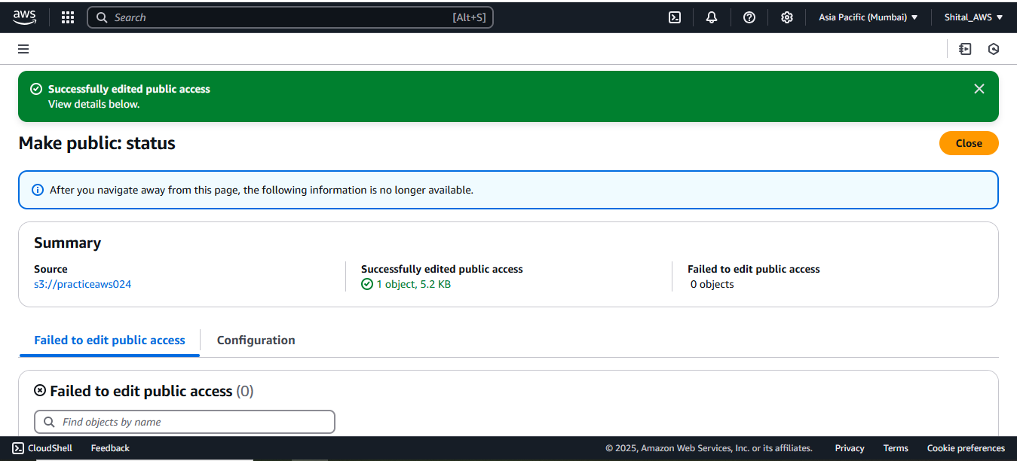

**Static web hosting**

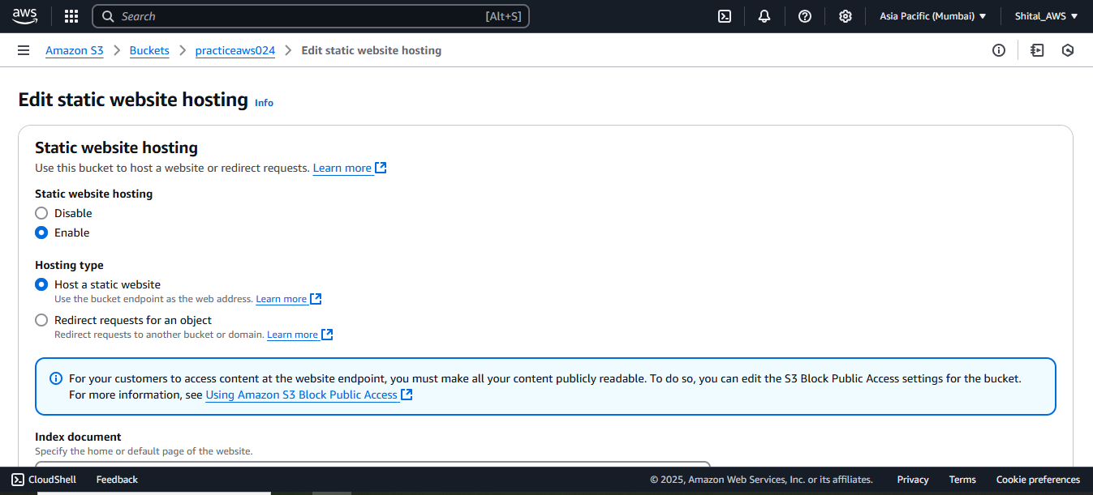

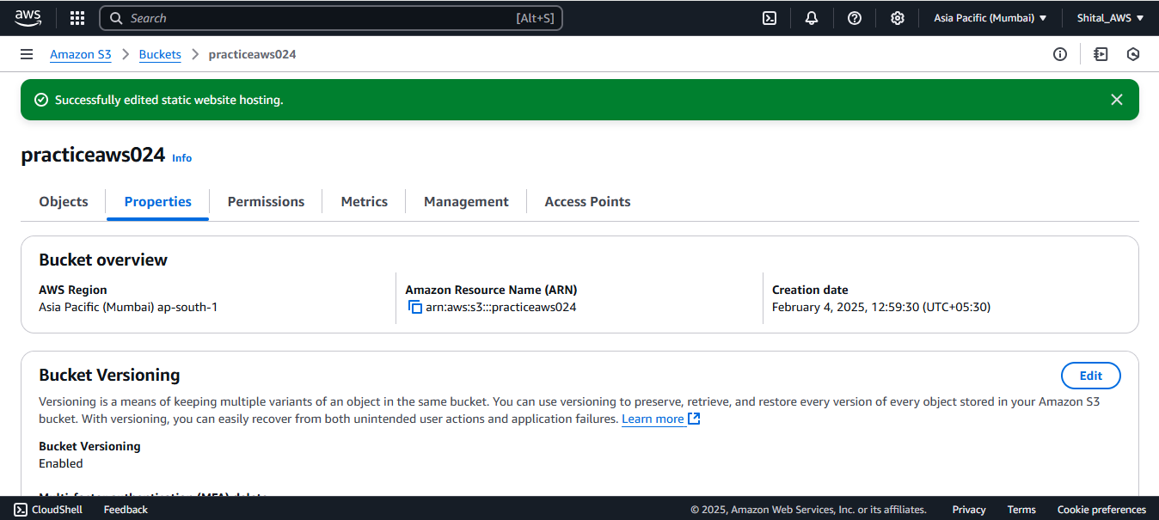

**Static Website hosted ,index.html is opening**

